OSSP PRACTICAL_5

Task-1

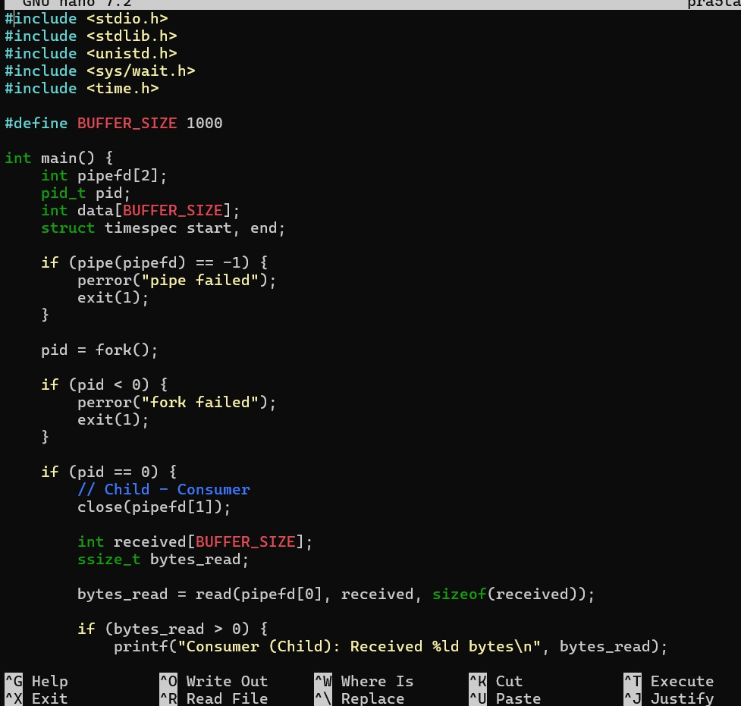
Implement a producer-consumer communication system using anonymous pipes where the parent process generates data and the child process consumes it. Measure the communication efficiency.

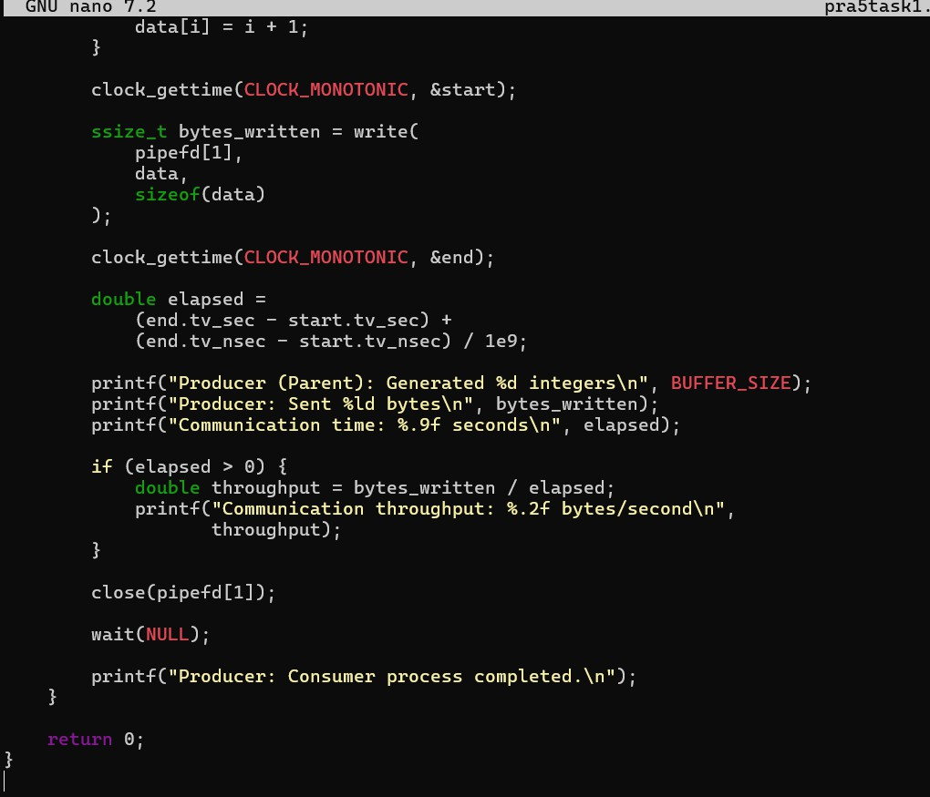
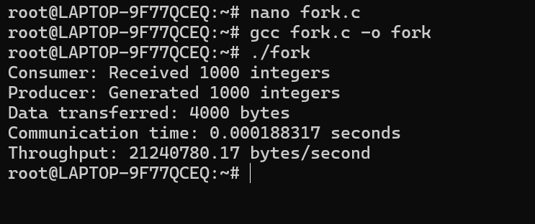

Observation

- An anonymous pipe was successfully created for communication between the parent and child processes.
- The parent process acted as the producer and generated 1000 integer values.
- The child process acted as the consumer and read the data from the pipe.

- The parent and child communicated successfully without using a shared file.
- The communication time was measured using clock_gettime().
- Communication throughput was calculated in bytes per second, providing a measure of communication efficiency.
- The parent used wait() to synchronize with the child and ensure that the consumer completed before the parent terminated.
- Thus, anonymous pipes provide a simple and efficient one-way inter-process communication (IPC) mechanism between related processes.

Task -2 Develop a program that executes the equivalent of the shell command: Is -l grep using fork(), pipe(), dup2(), and exec() system calls.

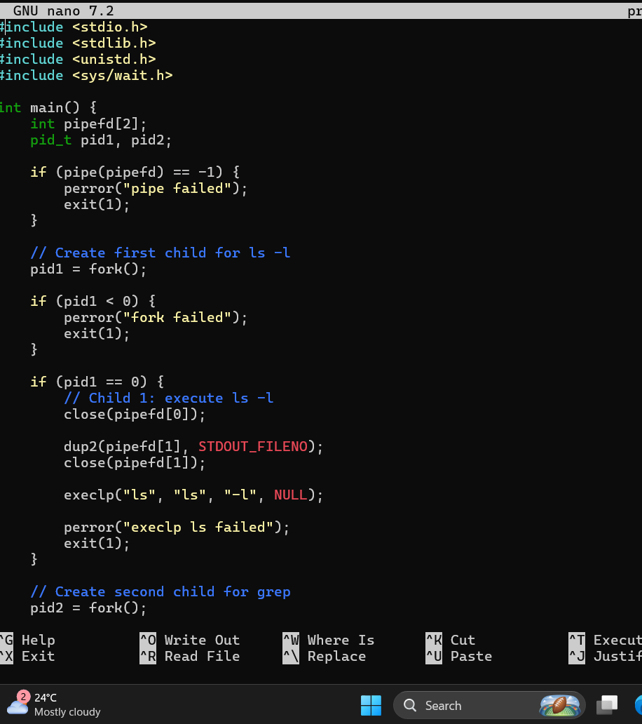

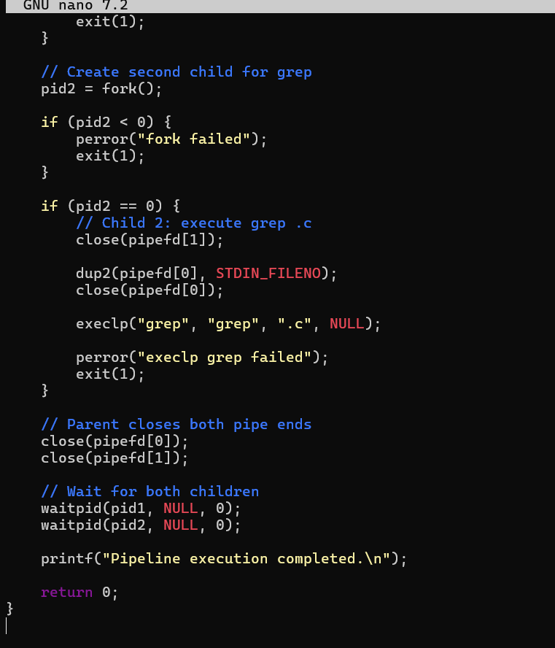

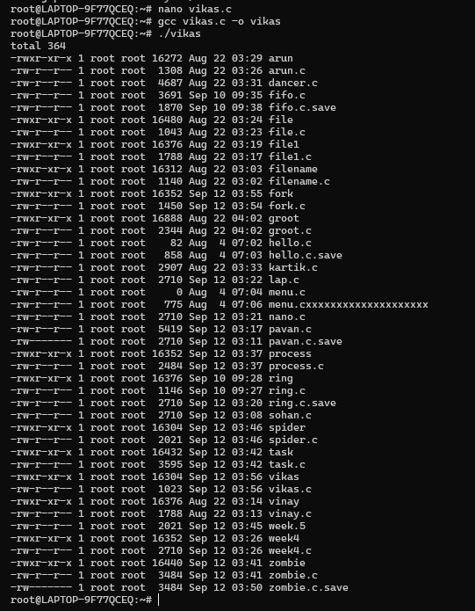

Observation

- A pipe was created using the pipe() system call to establish communication between two child processes.
- The first child used dup2() to redirect its standard output to the pipe and executed ls
-l using exec().
- The second child redirected its standard input from the pipe using dup2() and executed
grep .c using exec().

- The output produced by ls -l was therefore passed directly to grep, just like a normal shell pipeline.
- The parent process closed the unused pipe ends and used waitpid() to synchronize with both child processes.
- The program successfully demonstrated IPC using pipes, file-descriptor redirection using
dup2(), process creation using fork(), and command execution using exec().

